CLAIM SUBMISSION PROCEDURE
1) All claims should be submitted before the 20th of the month.
2) Click the link below and upload all the claims (receipts, etc.) in your respective folder. https://drive.google.com/drive/u/0/folders/1khhb6IIrkFdRG_XFtfgKwvlfcAN37VGg
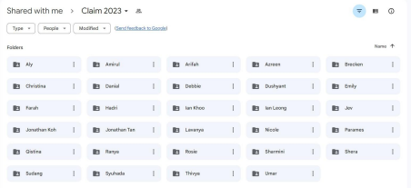

3) Once you have uploaded the claim attachments, open the Slack times-announcement channel, and you an find the claim options at the message bar at the bottom.

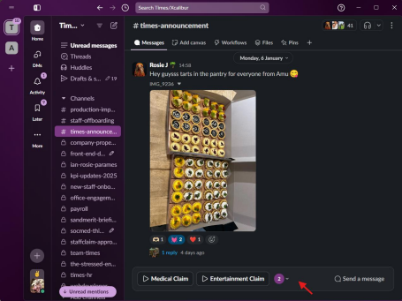

4) Click on the relevant claim option, complete the necessary fields, attach your claim folder link in the attachment column, enter the total amount, and click submit.

